PATIENT COMMUNICATION KIT
Menopause Awareness Month & World Menopause Day
Ready-to-use emails and newsletter snippets for miraDry providers to send to patients this October.
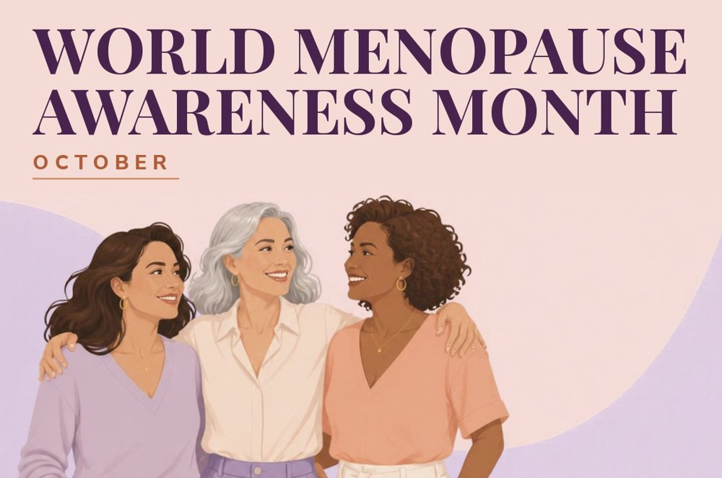

How to use this kit
- Email 1 introduces Menopause Awareness Month. Send it in the first week of October.
- Email 2 highlights World Menopause Day, which falls on Sunday, October 18. Send it the week of October 12.
- Newsletter snippets are short blocks you can drop into a newsletter you already send. Use one or several.
- Copy inside the shaded boxes is ready to paste. Replace anything in [brackets] with your practice details.
- Keep the source line with any statistic you use, and review all copy with your practice’s compliance or marketing team before sending.
PLACEHOLDERS TO FILL IN
- [Practice Name] – your practice name as patients know it
- [Provider Name] – the physician or provider signing the email
- [Booking Link] – your online scheduling page or consultation form
- [Phone] – your front desk number
EMAIL 1

Menopause Awareness Month
Send: first week of October Goal: open the conversation and invite a consultation
SUBJECT LINE OPTIONS
- October is Menopause Awareness Month. Let’s talk about the symptom no one mentions.
- Nearly 70% of women notice this during menopause
- Hot flashes get the headlines. Underarm sweat deserves a conversation too.
PREVIEW TEXT
You’re not imagining it, and you don’t have to just cope with it.
EMAIL BODY
Hi [First Name],
October is Menopause Awareness Month, a time to talk openly about the changes so many women experience and too often brush aside as “just part of life.”
Hot flashes and night sweats get most of the attention. But there’s another change many women notice and rarely bring up with their doctor: more underarm sweat and odor.
If that sounds familiar, you’re far from alone. The 2025 Sweat Scope study by miraDry and the International Hyperhidrosis Society found:
- Nearly 70% of women are believed to experience an increase in underarm sweat and odor during menopause.
- 1 in 5 women say they are always self-conscious about it in social or professional settings.
- 49% rely on three or more coping techniques, like extra deodorant, outfit changes or sticking to dark colors, just to get through the day.
Coping every day isn’t the same as solving the problem. At [Practice Name], we offer miraDry®, a non-surgical, in-office treatment that targets the sweat and odor glands in the underarm, with results that can last.
This month, give yourself permission to stop just managing it. We’d love to talk through your options.
EMAIL 2

World Menopause Day, October 18
Send: week of October 12 Goal: tie the date to action and drive bookings
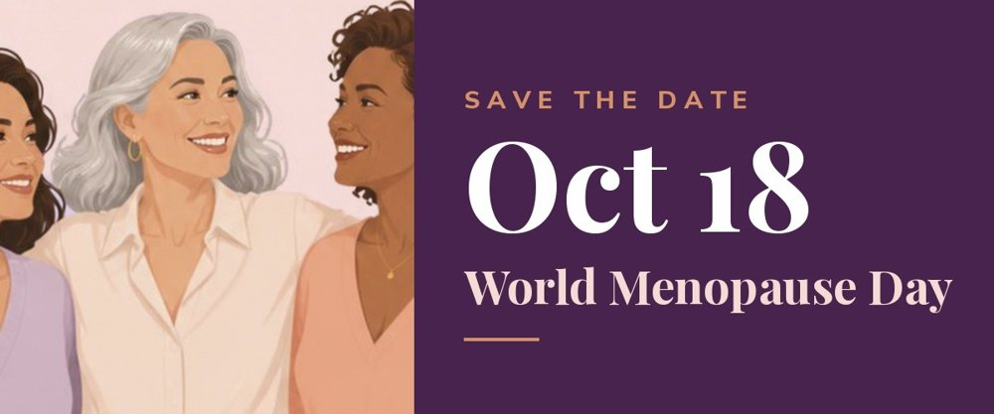
Suggested header image for this email
SUBJECT LINE OPTIONS
- This Sunday is World Menopause Day
- October 18: a day to stop “just dealing with it”
- World Menopause Day is almost here. Here’s one thing worth asking about.
PREVIEW TEXT
Many women are coping in silence. You don’t have to.
EMAIL BODY
Hi [First Name],
Sunday, October 18 is World Menopause Day, a global moment to recognize the symptoms of menopause and the women who live with them.
For many women, those symptoms include more underarm sweat and odor. It’s common, and it can affect how you feel at work, with friends and in what you choose to wear. Yet it’s one of the symptoms women mention least.
In the Sweat Scope study, 1 in 5 women said they are always self-conscious about their underarm sweat and odor, and nearly half use three or more coping techniques to manage it. Because menopausal women are often left out of sweat research, the true numbers may be even higher.
As one participant, 48, put it: “In the past, it seemed that a lot of symptoms were dismissed as not needing any treatment and just a part of life that we have to deal with.”
It doesn’t have to be that way. miraDry® is a non-surgical, in-office treatment for underarm sweat and odor, and our team at [Practice Name] is here to answer your questions.
This World Menopause Day, take one step for yourself: book a consultation and find out if miraDry is right for you.
Warmly,
[Provider Name]
[Practice Name] | [Phone]
Source: miraDry and International Hyperhidrosis Society Sweat Scope Study, December 2024, N=138.
CALL TO ACTION
Button text: Schedule My Consultation
Alternate: See If miraDry Is Right for Me
Link: [Booking Link]

NEWSLETTER SNIPPETS

Drop-in content for your existing newsletter
Each snippet stands on its own. Pick the length that fits your layout, and link the call to action to [Booking Link].

Snippet 1: Short (1–2 sentences)
Best for: a news roundup, sidebar or footer banner
October is Menopause Awareness Month. Nearly 70% of women are believed to notice more underarm sweat and odor during menopause. Ask us about miraDry®, a non-surgical treatment that can help.
Book a consultation →

Snippet 2: Medium (one paragraph)
Best for: a feature slot in a monthly newsletter
Let’s Talk About Sweat
Hot flashes get the headlines, but many women also notice more underarm sweat and odor during menopause. In a study by miraDry and the International Hyperhidrosis Society, 1 in 5 women said they are always self-conscious about it, and 49% use three or more coping techniques just to get through the day. If this sounds familiar, you don’t have to just manage it. miraDry® is a non-surgical, in-office treatment for underarm sweat and odor, available here at [Practice Name].
Schedule your consultation →

Snippet 3: World Menopause Day reminder
Best for: any issue sent in the two weeks before October 18
Mark Your Calendar: October 18 Is World Menopause Day
World Menopause Day is a chance to talk about the symptoms that too often go unmentioned, including increased underarm sweat and odor. If it’s something you’ve been coping with, this is a great time to ask us about your options.
Book a visit →

Snippet 4: Stat spotlight
Best for: a visual callout box or infographic-style block
Menopause & Underarm Sweat: By the Numbers
- ~70% of women are believed to experience more underarm sweat and odor during menopause
- 1 in 5 are always self-conscious about it in social or professional settings
- 49% use three or more coping techniques to manage it
You don’t have to just cope. Ask us about miraDry®.
Source: miraDry and International Hyperhidrosis Society Sweat Scope Study, December 2024, N=138.

Snippet 5: Patient voice
Best for: a pull-quote or testimonial-style block
“In the past, it seemed that a lot of symptoms were dismissed as not needing any treatment and just a part of life that we have to deal with.”
– Sweat Scope study participant, 48
Menopause symptoms deserve real answers, including underarm sweat and odor. This Menopause Awareness Month, talk to us about miraDry®.
Learn more →

BEFORE YOU SEND
- Include the source line wherever you use a Sweat Scope statistic. The ~70% figure is an estimate from the study authors, so keep the “believed to” wording.
- Have your compliance or marketing team review the final copy, including any offer.
- Want matching social graphics? Download the Menopause Awareness Month and World Menopause Day social kit: media.miradry.com/web/391932c0eae3dc4/menopause-awareness-month-day-2026-social/
- Full study: miradry.com/sweatscope2025

